Drevnyo Kyivska Vodka Marketing Plan

Prepared for
Ivan Surjanovic
BADM - 470

Prepared by

Mike Cerka, Valeria Efimova, Jared Lee, Mairin Platt, Cecile Wong
2009
VYBe

Table of Contents
Executive Summary 1
Current Situation 2
Problem Identification 2
Opportunity 2
Situation Analysis 3
Competitor Analysis 3
SWOT for Smirnoff 4
SWOT for Ketel One 5
SWOT for Grey Goose 6
SWOT for DK Vodka 7
Perceptual Map 9
Key Recommendations for Action 10
Brand Image 10
Positioning Strategy 11
Positioning Slogan Possibilities 11
Price 11
Distribution 12
New Name, Bottle and Label Design 13
Competitors’ Bottle Designs 14
DK Old and New Bottle Designs 15
Marketing Campaign 17

Internet Marketing 21

Evaluation Measures 23

Schedule 24

Campaign Budget 25

Conclusion 25

Appendix A – Pricing Comparison 26

Appendix B – Location Options 27

Works Cited 28

Executive Summary
Drevnyo Kyivska Vodka, which has a successful history in Eurasia, will soon be launched in British Columbia, Canada with the intention of eventually expanding to the rest of the country. VYBe Consulting Firm has prepared a comprehensive plan for the development of brand awareness and marketing of this new-to-Canada premium vodka.
The Canadian vodka market is currently saturated with a variety of products and Drevnyo Kyivska Vodka will be entering it with virtually no local brand awareness. To capture market share, Drevnyo Kyivska Vodka must establish and cultivate a strong brand image. This report details the best routes to achieve this. At the outset, to appeal to a Canadian market, the company should shorten the name to DK Vodka and display a more contemporary label and bottle than what currently exists.
An analysis of the current competition for DK Vodka is presented that focuses on three of the most popular vodkas sold in Canada today. Using SWOT analyses, the particular strengths and weaknesses of DK Vodka in the light of this competition are examined. Key threats and key opportunities are identified, for example, there is tough competition for DK Vodka but its unique qualities bode well for success. There is definitely a significant market opportunity for an attractively priced premium vodka.
Specific recommendations for action follow that emphasize the necessity for a strong brand image, well-defined positioning strategy and slogans, attractive pricing, and select distribution locations. Taking into account that DK Vodka is a high quality vodka product targeted at the upscale market segment consisting of both youthful and mature professionals, business people and others with an affluent lifestyle, a wide range of marketing strategies is then presented.
Many of the marketing strategies that VYBe recommends are geared toward the prestigious market of high-end hotels, restaurants, bars and clubs. For example, we recommend hosting a grand opening gala at a special luxurious location, complete with a fancy vodka ice sculpture display that pours chilled DK Vodka for guests. The marketing opportunity for DK Vodka offered by the 2010 Olympics is also identified.
Internet marketing is essential today and VYBe explores suggestions for implementing this such as website creation plus examines methods of how to improve the quantity and quality of traffic to the website.
Finally, appropriate methods to evaluate the success of the marketing campaign are specified plus a campaign budget and a schedule that recommends dates for the various stages of the promotional efforts.
VYBe is convinced that DK Vodka will be heartily welcomed in Canada and confident that DK Vodka will acquire a powerful brand image and a very healthy market share in the near future.
Drevnyo Kyivska Vodka

Current Situation
Drevnyo Kyivska Vodka (hereinafter referred to as DK Vodka) is new to Canada. Made in the Ukraine using a 150-year-old Russian recipe, DK Vodka has established itself as a popular brand of vodka in the Ukraine, Russia and throughout Eastern and Western Europe. DK Vodka’s current goal is to expand into Canada with its premium vodka at an affordable price.
DK Vodka in Canada plans to target a prestigious market consisting of high-end nightclubs, hotels, restaurants, golf and country clubs and the demographic that frequents those establishments: youthful and mature professionals, business people, and others with an affluent lifestyle. The company will begin operations in British Columbia with the future intention to expand into the rest of Canada.

Problem Identification
The fundamental problem that DK Vodka faces is entering into a saturated North American market with absolutely no brand awareness. A strategic plan for acquiring significant market share is essential.

Opportunity
Because DK Vodka is entering an entirely new market, it has the opportunity to build everything from square one including: brand, name, image, and marketing strategies.

The first step is to create a brand for DK Vodka whereby DK Vodka will begin to establish a connection with its market. The branding goal is to place DK Vodka front and centre in the minds of its target consumers when they are thinking of buying premium vodka for their establishments, parties, special events and getaways.
Secondly, the name Drevyno Kyivska Vodka is unwieldy for Canadian consumers. Shortening the name to the snappier and sharper “DK Vodka” will help in establishing brand and image. In conjunction with this, creating a new label is essential.
Thirdly, DK Vodka will need to create a prominent, long-lasting image of the product in the minds of consumers. For example, another vodka distributed in Canada, Grey Goose Vodka, has a website that can draw and hold the attention of even a non-drinker, because the image of the product is so mesmerizing. DK Vodka must develop an image that enhances the product’s prestige value and “aura” and captivates its target market.
Finally, to activate and proliferate such an image for its product, DK Vodka must implement clever marketing strategies.

Situation Analysis

DK Vodka is entering into an entirely new market segment and country where the target market already has vodka preferences. Therefore, it is essential to conduct a SWOT analysis of both the competition and DK Vodka in order that the company obtains a clear view of its new environment. An industry analysis will help DK Vodka to both understand the nature of its competition plus help it to create the right brand awareness for its own vodka.

There are currently many brands of vodka in Canadian liquor stores. Vodka is a very popular spirit attributable in large part to its neutral flavour and versatility as a mixer. Many brands are moderately priced and destined to be mixed with beverages such as orange juice or mixed in martinis and other cocktails. Other vodkas are more expensive and consumed chilled, either neat (“straight-up”) or on ice (“on-the-rocks). Flavoured vodkas have also become well liked. DK Vodka has potential competition from a wide range of pre-existing vodka products in its chosen environment. Surveying this competition will help DK Vodka understand how to best penetrate its new market.
Competitor Analysis
Most of today’s vodka is distilled from grains such as rye and wheat or from potatoes or beets. After distilling, the vodka is filtered, usually through charcoal. Repeated distillation and filtering improves the clarity and taste of the vodka. Hence, the more expensive vodkas tend to be those that have been subject to several distillation and filtering processes. Vodka is generally diluted with water before it is bottled because it has such a high percentage of ethanol (95-96%).

Vodkas are considered to be neutral spirits, “without distinctive character, aroma, taste or color.” Nevertheless, consumers do differentiate them according to alcohol content, taste, but most significantly, price. There are three broad categories of vodka according to price and it is useful to DK Vodka to see where its product is situated amongst these categories.

VYBe has completed an environmental scan of three price ranges of vodka in British Columbia – lower range, mid range and premium priced. (See Appendix A for the complete list and prices of vodkas in 750ml bottles.)

To best indicate the nature of the competition, we have selected three of the most popular vodkas, each from a different price category, for a detailed SWOT analysis.

Lower price range: Smirnoff

Mid price range: Ketel One

Premium price range: Grey Goose

The following discussion and charts indicate the results of this analysis for Smirnoff, Ketel One and Grey Goose.

Lower Priced Vodka

The vodka business is saturated with brands at the lower end of the price spectrum, with a 750ml bottle costing in the low to mid $20.00 range. Smirnoff Vodka is the most popular in the lower price category. Originally founded in Russia, Smirnoff is now produced in the United States with a grain base and de-mineralized water and filtered through charcoal. Smirnoff’s trademark is a sharp advertising campaign. One of their most famous slogans was “the classic double entendre tag line: Smirnoff — It leaves you breathless."

SWOT for Smirnoff

KEY Strengths | KEY Weaknesses
- Inexpensive  - Competitively priced  - Brand loyalty from younger demographic  - Many different options of the vodka (various flavours)  - # 1 provider of vodka in the world  - excellent marketing | - Lower quality vodka  - Lower price could be denoted as a cheaper product
KEY Opportunities | KEY Threats
- Expansion (more flavours) | - Very saturated low end spectrum

Mid Priced Vodka
Vodkas in this price category cost from the mid $30.00 range up to the low $40.00 range for a 750ml bottle. This spectrum is the least recognizable in brands and is not as strategically placed as the low range and premium range brands are. Ketel One, priced at $39.95, is produced by the Nolet family in Holland and is made from wheat. It is triple distilled and charcoal filtered.

SWOT for Ketel One
KEY Strengths | KEY Weaknesses
- Good quality  - Hand crafted in small batches  - Brand loyalty  - Long-time family business, 300 years  - Competitive marketing campaign | - Middle priced – positioned in the middle, not the most expensive, but also not the least. Middle of the road, rather than premium or a bargain  - Middle Quality – middle range product  - Lacking options of different flavours
KEY Opportunities | KEY Threats
- Small middle range vodka category, open for expansion and possible taking over of that spectrum | - Better quality vodka products  - Better priced vodka products  - Threat of new entrants into the middle spectrum due to smaller competition

Premium Priced Vodka
The market is less saturated when we examine more prestigious and higher end brands priced from the high $40.00 range up to $69.00. Most of the brands that produce premium vodka are distilled at least five times. The most recognizable brand in this category is Grey Goose Vodka, which is priced at $50.99 for 750ml. Some of the other recognizable brands in this category are Belvedere, Chopin and U’Luvka vodka.
Grey Goose was targeted at the American market in 1997 by Sidney Frank with the intention to provide a premium vodka. Now owned by Bacardi, Grey Goose is produced in Cognac, France, and uses a five step distillation process with French winter wheat from the south of Paris and alpine spring water filtered through champagne limestone. Its higher price is connected with a perception of quality and prestige.

SWOT for Grey Goose
KEY Strengths | KEY Weaknesses
- Very good quality  - Brand loyalty from prestigious market  - A few different options of vodka (different flavours)  - Claims to be best tasting vodka in the world (own the market)  - Competitive marketing campaign | - High price  - Not the highest quality in the prestigious market
KEY Opportunities | KEY Threats
- Expansion in the prestigious market (more flavours) | - Better quality vodka products taking over

SWOT for DK Vodka
The primary competition for DK Vodka is most likely Grey Goose since the two brands are similar products in the same category of premium vodkas and priced almost identically with DK Vodka at $49.00 and Grey just $1.99 more. Fortunately, DK Vodka has some special qualities that distinguish it from Grey Goose. DK Vodka is made from winter wheat and soft water from the Kyiv region of the Ukraine. Handcrafted using a 150-year-old Russian recipe and a 500 year old distillation process, DK Vodka is filtered five times through quartz, not charcoal, to obtain a very high degree of clarity and purity.

KEY Strengths | KEY Weaknesses
- High quality product  - Unique – filtered 5 times through quartz, soft, Kyiv region water  - Competitively priced  - Competitive edge  - WOW factor: Fresh, exciting, both classy and subtly sexy  - Established target market in the Ukraine | - Product has absolutely no brand awareness in Canada  - Not established in the liquor industry as premium vodka  - No existing distribution channels
KEY Opportunities | KEY Threats
- Niche market of prestigious quality at a lower price  - No previous perception of the vodka in Canada. DK can create any image that they want.  - Expansion of the product (flavoured vodka)  - Creation of a unique brand | - Has no prior reputation in Canada,  - Lower price could be denoted as a cheaper product  - Brand loyalty to other vodka products  - Difficulty in penetrating the saturated vodka market

Environmental Scan Summary
VYBe’s environmental scan has determined that DK Vodka has certain competitive advantages over other vodkas in the British Columbia market. As a premium brand, it outclasses vodka in the lower and mid price ranges. Its prime competition in the premium category is Grey Goose but DK Vodka has a unique filtering process, through quartz, unique wheat and water, plus it is priced slightly less than Grey Goose.
Based on the SWOT analysis of other well-known vodka brands plus DK, VYBe was able to create a perceptual map that indicates the market positions of various vodka competitors plus just how competitive DK Vodka has the potential to be. Furthermore, this analysis allows us to suitably tailor the branding and promotional campaign.

The perceptual map that follows situates a number of the most popular vodkas in Canada with respect to quality and price. DK Vodka occupies a prominent place at the top end of high quality yet is positioned with a surprisingly moderate price tag that is not commensurate with its premium quality. In other words, compared to its competition, DK Vodka is a high quality product at a relatively low price.
Perceptual Map
DK Vodka
High Quality

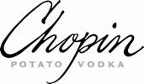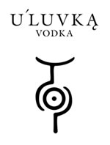
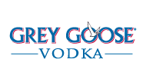
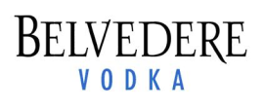
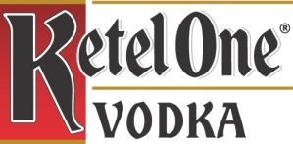
High Price
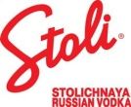
Low Price
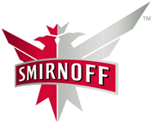
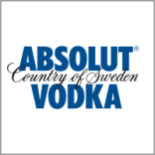
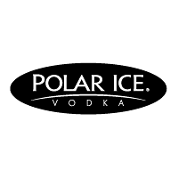

Low Quality
Key Recommendations for Action

- Establish a brand image
- Develop a positioning strategy
- Create slogans
- Define distribution channels
- Implement name and label change
- Launch a website and initiate internet marketing strategies
- Create a viral and social marketing campaign
  - Incorporate the branding and positioning strategies to help create a campaign
  - Incorporate online (social media) strategies to contribute to viral marketing

Brand Image
“Brands are among a firm’s most valuable assets because they link products to desirable associations such as quality, trust or prestige.”
Brand images can be very powerful in influencing consumers’ choices. Establishing a distinct brand image is clearly essential in marketing DK Vodka although it must be recognized that it will time to develop a solid reputation.

The brand image should focus on the quality and the unique features of DK Vodka, not the price. However, a strong brand image can add value to DK Vodka and help to sustain the marketability of its $49.00 price. It can also appeal to the consumer: i.e. convincing consumers that choosing DK Vodka will enhance the consumer’s status.

The name plus the label and design for the DK bottle are important components for the brand image and are discussed under a separate heading below.

Initially, DK Vodka can capitalize on the fact that it is a prestigious vodka. For example it was considered so valuable that it was presented to former US President Bill Clinton as a gift from Russian officials. Furthermore, DK Vodka can emphasize the “WOW” factor by presenting it as a subtle, sexy new vodka on the market, that promises excitement as well as being classy. Building a successful image will be enhanced if consumers feel an emotional connection with DK Vodka and appreciate it as much for its symbolic value (prestigious, exciting) as for its intrinsic qualities.

Positioning Strategy
DK Vodka must define its own distinct positioning in the market by establishing itself in the minds of its potential customers as having unique and desirable attributes. The market segment that DK wants to compete in has room for a creative company to make and attain a distinct position. DK needs its vodka to be perceived by its higher-end target market as exceptional, premium vodka at a competitive price.
To position itself accordingly, DK’s strategic positioning must emphasize how unique its product is. DK can claim that its vodka is unique in both quality and value because DK Vodka:
- is an entirely new imported vodka, simultaneously classy, exciting and subtly sexy
- is handcrafted in the Ukraine with a special Russian recipe using a 500 year old process
- has an outstandingly pure quality with 5x filtering through quartz
- has a remarkably attractive price
- is an exquisite product that sets a new standard
DK Vodka should be offered to the target higher end market as a quality leader. If DK Vodka is perceived to be an exclusive product at an attractive price, the target market will act on this perception to select DK Vodka as their preferred vodka.

Positioning Slogan Possibilities
- DK Vodka: Peerless
- Pure vodka for pure pleasure
- DK Vodka: Exquisitely Pure
- DK Vodka: Ukraine’s best kept secret
- DK Vodka: Perfect Pure Precious
- DK: The World’s Smoothest Vodka
- Smooth Subtle Stimulating: DK Vodka

Price

The price of $49.00 gives DK Vodka a competitive edge and will facilitate penetration of its targeted market segment. DK wants to be seen as prestigious and of the highest quality but still obtain a decent size of the market. A pricing strategy of being within the highest range yet attractively priced is an excellent form of penetration pricing.

The example of Grey Goose, which entered the market at the $50.00 range, is useful. The Grey Goose case showed that setting a price high encourages the market to perceive the product as having a higher quality than lower priced products of the same type. Consumers are willing to pay more for a product that they perceive as superior.

Although using a similar pricing strategy, DK Vodka will have the edge over Grey Goose because its price will be slightly lower. Undercutting its main competition with penetration pricing should allow DK to gain market share.

Furthermore, DK Vodka’s attractive price combined with high quality places it in a distinctive area on the consumers’ perceptual map.
Distribution
DK Vodka will ultimately be strategically distributed throughout Canada but initially in British Columbia. The DK Vodka brand is geared towards a higher end market and to consumers who prefer premium vodka. These consumers tend to frequent establishments such as five star hotels, fancy clubs and restaurants plus golf and country clubs.
Accordingly, the distribution plan and marketing campaign will target prestigious places such as Shangri-La Hotel’s restaurants and bars, the Sheraton, Four Seasons and Hyatt hotels and resorts, Lux Lounge, Ginger 62 Nightclub, Blue Water Café, Lumiere restaurant, and Capilano Golf and Country Club amongst others. (See Appendix B for a more complete list.)
We plan on choosing these locations for several reasons:
- They will facilitate the branding of DK Vodka as a premium vodka
- DK Vodka will gain exposure to business people and tourists who come from all over Canada and the globe.
- This will encourage word of mouth publicity emphasizing the lasting memory of having the best vodka at the choicest locations that British Columbia has to offer.
- Honing DK’s brand image at tony night clubs and private clubs will disseminate awareness of DK Vodka amongst a critical component of the target market
- Younger, trendy consumers will experience DK Vodka as an upscale beverage that can enhance their own prestige. Brand recognition amongst this market segment will create a base for future growth.
- High profile placement in upscale establishments will increase brand awareness and encourage consumers to make private purchases at BC Liquor Stores.
The objective of this distribution strategy is to:
- nurture customer awareness of DK Vodka amongst a specific market segment – higher-end consumers
- create brand loyalty to DK Vodka
- acquire and expand market share of DK Vodka
- encourage British Columbia customers to gain experience with DK Vodka and begin to spread the word about what a spectacular vodka it is
Once DK Vodka has begun to acquire brand loyalty and a significant market share in British Columbia, distribution channels will be opened up throughout Canada.

New Name, Bottle and Label Design

To distinguish a new vodka brand amongst the many varieties of vodkas on the market in Canada, it is essential to have a catchy name, bottle and label design. To help establish the Drevyno Kyivska brand in Canada, we believe that it is necessary to adjust the name and create an entirely fresh and new label and bottle design.

Drevnyo Kyivska, which translates into English as “Ancient Kiev”, is a difficult brand name for Canadian consumers to articulate. The snappier and sharper “DK Vodka” rolls off the tongue easily and its simplicity will help in establishing brand image.

A novel and captivating label will enhance the consumers’ ability to recognize the brand within the category and help to strengthen the brand’s presence in buyers’ memory. Thus it is important that the name on the bottle and any advertisements or logos should specifically draw attention to “DK Vodka”.

There are many different looks and styles that can be incorporated into the design as you can see from the illustration on the next page that shows the design of various competing brands. We feel it might also be a good idea to choose a bottle design with an interesting shape. A curved bottle or a tall triangle bottle would be very catchy and when consumers are purchasing it will stand out against competitors even if they do not know the brand.

As illustrated below after the competitors’ bottle designs, our two sample label designs for the new bottle focus on the letters “DK” while retaining the original name on the bottle. On the first of our options we wanted to incorporate the Ukrainian national colors so we put a small flag on the label. On the second, we opted for an unusual stylish bottle shape with a simple but bold label that stands out. The two samples provide examples of how to begin establishing a new brand image. Both are more suited to the Canadian context than the old bottle design, also illustrated below.

Competitors’ Bottle Designs

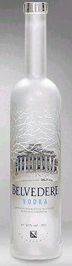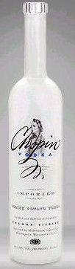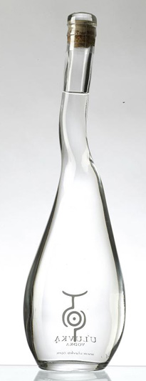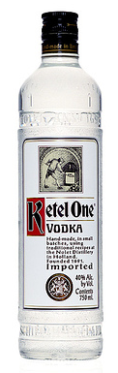
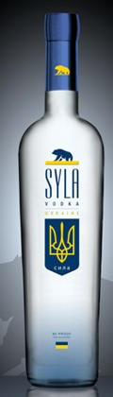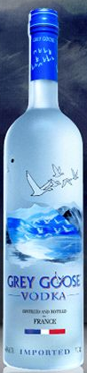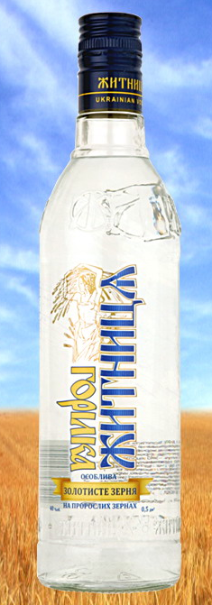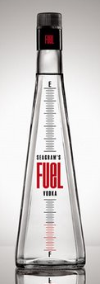

DK Old Bottle Design DK New Bottle Design-1st Option

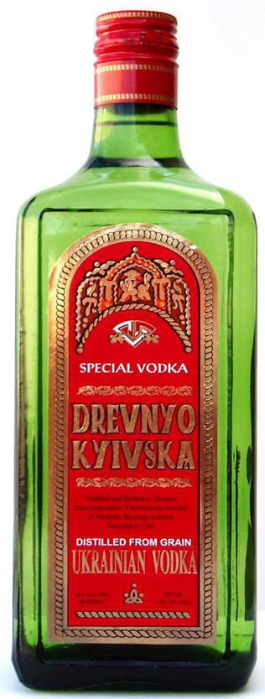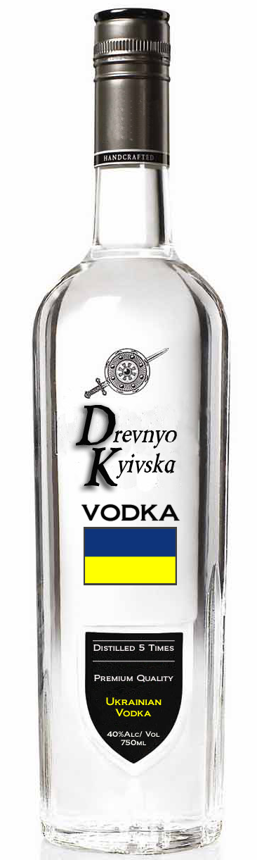

DK New Bottle Design-2nd Option

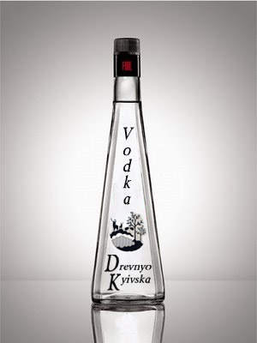

Marketing Campaign

VYBe Marketing and Consulting has put together a variety of marketing ideas for DK Vodka. These ideas range from traditional marketing techniques to more innovative ideas that involve viral and guerilla marketing. Some of the ideas can be used together and some of them relate to different target market segments.

- Launch a DK Vodka “story” to be circulated via “viral” methods (word of mouth). For example:
“DK premium vodka is the purest vodka with the ultimate clarity and smoothness…quartz filtered 5 times… imported from the Ukraine, gifted to former US President Bill Clinton. “

- Create a video to post on the Internet and YouTube that will have a massive shock factor or display something incredibly hilarious. The idea is for the video to be so stimulating for the viewer that they feel the need to pass it on in a “viral” manner.

Starting the initial spread of the video and story can be done through personal emails, posted on blogs, Facebook, Twitter, and other social media websites and if the message is successful it will spread to reach a large audience. It is also important to show the company name, slogan, and website at the end of the short video and try to direct people to your website to find out more information.

Potential Ideas for the video:
  - Golf video where a golfer swings and yells FORE, then a man turns around and gets hit in the groin by the golf ball. Then he ends up on the patio of the golf club drinking and a slogan says something like “DK Vodka – the purest vodka for the purest of moments”
  - Two businessmen have a meeting that ends up in a bar. Various quick clips are shown of them having several drinks and one man is shown only drinking DK Vodka, while the other is drinking various other cocktails. The next morning one guy is passed out or severely hung-over, while the DK vodka drinker is in the 8am meeting with no hangover and wondering where his partner is.
  - To a younger target market – very fast 1 second clips of a college student’s day. Wake up, in class, eating food, talking to friends, go from bar to bar, drink after drink of DK Vodka, connecting with an attractive person. Then in class the next morning with no hangover.

- DK Vodka’s Grand Opening Gala – This event is not to be missed! We think it would be a very exciting introduction to the city of Vancouver to host a special evening in a prestigious location to introduce your product to the market. At this event, you would send an elegant invitation to all the managers, owners, and bartenders of all the exceptional restaurants, lounges, clubs, and other locations that have qualified to distribute your product. These are potentially the key people and clients that will be distributing your product and this is where you really want to WOW them. Choose the finest location for the event, provide a classy yet exciting atmosphere, include a fancy vodka ice sculpture display for DK (see pictures below), and try to create relationships with your potential clients. If you can succeed in wowing your customers and informing them of the exceptional premium quality of your product then they will pass this information along and provide a similar experience to their own clientele. Prior to this event, the goal is to create a buzz about DK Vodka and have people eagerly anticipating the event and DK’s introduction.

- Vodka Ice Sculpture Luge- In a very high-end restaurant/lounge we bring in a deluxe ice sculpture through which you are able to pour vodka and chill it to the perfect temperature. The vodka flows elegantly into a crystal glass at the bottom and the people get to taste the DK vodka! See the sample vodka luges illustrated below.

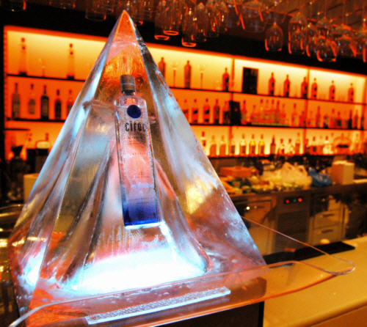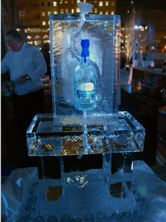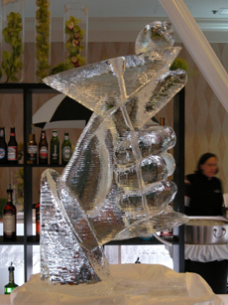
- Introduce “leaners” to specific high-end lounges, bars, and other classy establishments. A leaner is basically an undercover person working for your company that will go into the key establishments where the bar is very busy and he or she will lean to the bar and ask someone to buy them a DK Vodka beverage. Most of the time the person at the bar will do it for them. Then the leaner gives the person money, the person orders it, and then hands it back to the leaner. Now this person has had an experience with it and will likely ask, “What is DK Vodka?” And that is where the leaner inserts a key slogan – “It’s the purest Ukrainian vodka and it gives you no hangover.” This can be a very powerful form of marketing. If you send two-three leaners into a busy bar, you will likely have most of the people that are drinking vodka to be drinking your brand in a short period of time. Furthermore, this can help create a buzz around “no hangover” and get many people talking about it.

- Establish a DK Vodka marketing team to hit the hot spots around the city and hand out promotions and create brand awareness. Preferably you will have good-looking, well-groomed men and women to represent your product and you want to be in the targeted locations. For example, Heineken representatives recently came into the Lux Lounge, which is a high-end lounge on Granville Street in Vancouver, and they bought everyone in the bar free Heinekens for about an hour, and they also handed out free Heineken glasses to take home. I think this would be a great idea for a new product like DK because the customer likely doesn’t know of your product nor has tried it. It gives customers an opportunity to try it and also for the representatives to interact with customers and tell them personally about the product. It might also be a good idea to leave them with a shot glass, martini glass, or a martini stir stick to take home with the DK logo and slogan on it. This will make them remember the product and create a lasting image. This form of marketing is very personal and it can really create a wow factor for the customer. They get to enjoy a free beverage of premium quality, and take a gift home; not many will refuse this offer and most will be excited about it.

- Create a DK Vodka car for the representatives. When driving around the city, your logo and slogan are displayed and this will promote a very successful image. This can help create general awareness and people will think, “What is that company?” They might go home and look up the website or ask a friend about DK Vodka.

- Another effective form of marketing is shelf displays in bars, lounges, and restaurants. Many of these locations have elaborate shelves behind the bar that are filled with various bottles of alcohol and often displays for a certain brand. After doing research in a few locations in downtown Vancouver, we discovered that the cost to have a regular sized shelf dedicated to your brand is roughly $500 per month depending on the location. Another alternative is that you can provide a $5-$10 discount per case for your product and it will add up over the month or year. This form of marketing is relatively inexpensive compared to any print advertisement or any other form of media. In addition, it can be extremely effective because this is where many consumers are purchasing the product. Your brand is lined up directly in front of their faces when consumers are making their choice about what to purchase.

- Sponsoring and/or hosting social events can be another effective way to generate awareness and create a positive image for your brand. When doing an event, there are many key marketing tactics to keep in mind. Some of them are: create as much presence as possible by using banners, logos, and having walking representatives present, give away product samples, teach people about your product, create relationships, and wow the customers. Some ideas for events for DK Vodka are:

- Sponsor a golf tournament at one or many of the prestigious golf clubs in Vancouver
- Host a fundraiser for cancer or a charity of your choice. This can create a positive image around your brand and can attract free publicity in local media
- Sponsor social events such as art shows or other gatherings that appeal to the target market
- For a younger target market, you can sponsor specific club parties, boat cruises, or live music shows. If this is an option, you can focus on the prestigious locations such as Republic, The Modern, and Bar None in Vancouver. These locations are very high-end but also attract a relatively young crowd.

- 2010 Olympics: The upcoming 2010 Olympics in Vancouver and Whistler offer an excellent opportunity and platform to market DK vodka. People from all over Canada and the world are coming to visit BC to enjoy the finer things that BC has to offer. This will include finer liquor. Special DK events emphasizing Olympic themes leading up to and during this time are essential.

- Introduce a blind taste test. For this idea it would be a good idea to try a blind taste test amongst groups of friends and family where you compare DK to another brand of vodka such as Grey Goose. If people generally prefer DK, then it could be a great idea to spread the blind taste test to large groups of people. As long as the results are in your favor, then this will be effective because it gives people first hand experience with the product and you can talk about the benefits of drinking DK Vodka.

- Hand out samples in liquor stores. If you want to market to the mass consumers then this is a good method to introduce your brand. You will be able to interact with the consumer, let them try the product, inform them about it, and possibly hand out a promotional product if they purchase a bottle. This product could be a shot glass, martini glass, or a martini stir stick, and all would have the DK logo and slogan on it. Again, this can be very effective if they take home the promotional product because it provides customers with value and it will continue to remind them of your brand in their household every time they use it.

- Celebrity endorsement: Hire a celebrity. When consumers see one of their favourite celebrities endorsing a product, they are more likely to go out and buy the product and try it for themselves.

- Another alternative, if you decide to penetrate a slightly younger market with a fun and exciting brand, is including some kind of riddle or joke for people to solve and laugh about when they purchase the product. This could be a picture riddle under the lid (see picture below), or a peel back label that has a joke on the inside. Alternatively, the picture riddle could be in the bottom of the bottle and only revealed once the contents are consumed. The riddle or joke should be creative and funny for people to discuss when they are socializing and it is just one extra way to wow a customer and make them purchase your product. The following illustration shows the Mickey’s Beer company riddle.

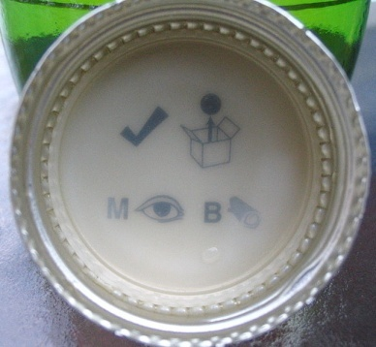
“Check out my blog”

Internet Marketing

Combined with traditional offline marketing techniques, Internet marketing can be very powerful and can reach a large market of people. The following is a list of ideas and strategies to create your online presence and enhance your brand. If you wish to follow through with these ideas we can provide you with the right tools or people to complete the job or you can choose your own web developers and marketers.

- Create a website – This is clearly the first step for establishing an online presence. To build a website with a limited budget it would be best to start with a basic site design that will include a home page, logo, slogan, pictures, product information, and contact information. Another idea to include on the basic site is a blog roll. This is more interactive with viewers and you can easily post news, events, and general updates to always have fresh content for viewers. Without a website, your brand will not look very professional and you can lose out on potential opportunities and generating leads.
- Search Engine Optimization (SEO) – SEO optimizes your position on search engines (such as Google) and helps improve the quantity and quality of traffic to your site. The idea is to improve your rank when people search specific key phrases and make sure you are on the first page because that is often as far as people look. You can improve this rank by many ways:
  - Have plenty of valuable and relevant content on your site that relates directly to the key phrases you want to optimize.
  - Insert and repeat (without over using) the key phrase in various locations on your website, not only in the content but also in the headings, title tags, meta tags, picture labels, hidden tags, and in the html address.
  - Also, you want to optimize different pages on your site for different phrases to attract a broader market from search results.
  - Increase the amount of incoming and outgoing links to your site. The more popular and relevant the links are, the more it will improve your rank. You can try linking with the websites of places to which you distribute your product such as restaurants and golf clubs etc.

- What key phrases should DK use? – After doing research on the popularity of specific phrases, we have determined some phrases to consider optimizing. These phrases are ranked in order from most frequently searched on Google to least searched, the phrases are:
- Vodka (by far the most popular searched phrase)
- Spirits
- Russian/Ukraine Vodka
- Vodka Cocktails – a little lower than Russian Vodka but this phrase is searched the most during the Christmas season
- Vodka Prices
- Premium Vodka
- Best Vodka drinks
- Best Tasting Vodka

The idea is that you want to optimize different links on your website to the most popular searched phrases so you can increase traffic to your website and create awareness of your brand. It might be hard to compete on the most popular phrase “vodka” but you should focus on a phrase that will be your niche. You can also add a page to your site that is focused towards “Vodka Cocktails” providing unique recipes and gain traffic that way.

- Exciting Video – As previously mentioned, creating a video that is funny or exciting for viewers can create a huge buzz on the Internet and get passed on to thousands of viewers. If a video is passed by emails or on blogs you can include the link to the DK website. This will increase traffic to the site substantially and people will be able to learn more about the product.

Evaluation Measures
After implementing our marketing strategies, we will follow up on how well the campaign has worked for DK Vodka.
- Preliminary monitoring of the success of the campaign from August 2009 until February 2010 via sales.
- Beginning February 2010, gather detailed data regarding brand awareness, sales, and market share
- Confirm the sales and market share at the locations where DK is available.
- End of May 2010: compare differences in the brand awareness, sales, and market share from February 2010.
  - Has brand awareness increased?
  - Have sales numbers increased?
  - Has market share increased?
- Fluctuating bar inventory of DK Vodka at select locations will be calculated to determine the links between the various methods of marketing and sales.
- Focus on a small number of chosen distribution locations that have been exposed to leaners. Request that these locations monitor the demand for DK Vodka with reference to before the “leaners” were introduced, compared to May 2010.
- Surveys of the target market will be conducted by VYBe representatives at hotels, restaurants, bars and clubs to evaluate brand awareness and purchase preferences. Surveys can simultaneously serve as a marketing tool if they are implemented in a fun way, for example, by giving out free samples of the product after the participants have completed the survey. A small keepsake bottle souvenir would help to keep top of mind awareness of DK Vodka.
- Website hits will be calculated to help determine extent of exposure
- Online surveys will be implemented directed at the target market to help assess the effectiveness of the Internet campaign
- Bartenders will be interviewed regarding their opinions on the strength of the brand image of DK Vodka

The timeline that follows will help guide implementation of the recommendations and evaluating the success of the campaign.
Schedule

Begin July 1st 2009
- Establish brand image
- Develop a positioning strategy
- Create slogans
- Define distribution channels
- Implement name and label change
Begin September 1st 2009
- Launch a website and initiate Internet marketing strategies
- Create a viral and social marketing campaign
  - Incorporate the branding and positioning strategies to help create a campaign
  - Incorporate online (social media) strategies to contribute to viral marketing
  - Create video

Begin October 1st 2009
- Launch viral and social marketing campaign. Including the following promotional options:
  - Leaners
  - Taste test
  - Marketing team
  - Social event sponsors
  - Grand opening gala

Begin November 1st 2009
- Begin direct targeting of 2010 Olympic vendors. Use tools such as:
  - Marketing teams
  - Social events sponsors
  - Taste tests

Begin January 1st 2010
- Launch video, create more hype/awareness
- Continue using recommended promotional tools

Begin February 1st 2010
- Gather information using predetermined performance measures for campaign and evaluate success of DK Vodka and its marketing strategies.
- Complete the above in advance of summer, in order to be prepared for summer demand for the product.

May 2010
- Evaluation: compare differences in the brand awareness, sales, and market share from February 2010
- Develop more marketing strategies for the summer and following year.

Campaign Budget

The estimated costs for designing and implementing the key recommendations and action plan are: $460,600. 00

The breakdown is as follows:

Design, produce and post the promotional video $100,000.00

Three Leaners, 3 nights/week at 10 different locations
from October to February $30,000.00

Marketing team of 6 people $100,000 .00
- Taste tests
- Shelf displays
- Hand out samples

Grand opening gala $50,000.00

Ice sculpture luge $600.00

Social Event Sponsorship $50,000.00

DK Car with decals $25,000.00

Internet marketing and web design $5,000.00

Label, bottle and name change $100,000.00

Please note: VYBe consulting fees are additional: 15% of the campaign budget.

Conclusion

VYBe is very excited about launching DK Vodka’s new marketing campaign. Introducing such an impressive new product creates a wealth of challenges and opportunities for innovative marketing strategies. We are strongly convinced that our marketing plan will facilitate the capturing and retention of a large market share amongst our target segments. DK Vodka promises to be a preferred beverage in the very near future. We are very much looking forward to growing a powerful DK Vodka brand image in British Columbia and then the rest of Canada.
Appendix A

Pricing Comparison – 750ml Bottles

Premium Brands
U’luvka – 69.00
Chopin – 54.99
Belvedere – 51.95
Grey Goose – 50.99
DK Vodka – 49.00
Vincent Van Gogh Espresso – 48.99

Mid Range Brands
Rain organic – 41.99
Ketel one – 39.95
Prairie organic – 37.99
3 Vodka – 36.99

Lower Range Brands
Stoli – 24.95
Wyborowa – 24.95
Absolut – 24.95
Sky – 24.45
Polar Ice – 24.25
Smirnoff Red Label – 23. 95
Alberta – 23.00

Appendix B – Location Options

Vancouver, BC
- Aqua Restaurant and Lounge
- Bacchus Restaurant and Lounge in the Wedgewood Hotel
- Bar None
- Blue Water Café
- Capilano Golf and County Club
- Capone’s Restaurant and jazz club
- Cardero’s
- Fairmont hotel
- Four Seasons Hotel
- George Lounge
- Ginger 62 Nightclub
- Hyatt Regency Hotel
- Lumiere Restaurant West Broadway
- Lux Lounge
- Marine Drive Golf Club
- Modern
- Opus Bar/Lounge
- Republic
- Section 3 Yaletown
- Shangri-La Hotel’s restaurants, bars and lounges
- Shaughnessy Golf and Country Club
- Sheraton Hotel
Whistler, BC
- Araxi Restaurant
- Barefoot Bistro
- Chateau Whistler Hotel and the Golf Club
- Il Camineto
- Nicklaus North Golf Course
- Trattoria Di Umberto
Vancouver Island, BC
- The Aerie Restaurant and Resort
- Bear Mountain Golf and Country Club
- Royal Colwood Golf Club
- Victoria Golf Club
- Vista 18 – Atop the Chateau Victoria Hotel
Interior of BC
- Gallagher’s Canyon Golf and Country Club, Kelowna (Okanagan)
- Greywolf Golf Course, Panorama
- Predator Ridge Golf Resort, Vernon (Okanagan)

Works Cited

All About Vodka. Copyright 2001-2009 Beverage Testing Institute.
<http://www.tastings.com/spirits/vodka.html>
BC Liquor Stores. 14 June 2009.
<http://www.bcliquorstores.com/en/products?keyword=vodka&gKey=All&pr=Any&pp=20&bc_region=Any&by=size&asc=0&pg=6>
DK Premier Premium Vodka of Russia. 1 May 2006
<http://www.lwdistributing.com/prod01.htm>
Grey Goose Wikipedia: The Free Encyclopedia. Wikimedia Foundation, Inc. 16 June 2009. <http://en.wikipedia.org/wiki/Grey_Goose_vodka>
Grey Goose Vodka. Copyright 2009 Grey Goose. <http://www.greygoose.com/#/canada/en/vodkas/vodkabottles>
Ketel One. 15 June 2009.
<http://www.thebar.com/en-us/drinks-by-brand/Ketel-One.aspx>
LW Distributing Company, Fine Wine and Distilled Spirits. 1 May 2006
<http://www.lwdistributing.com/prod01.htm>
Vodka Wikipedia: The Free Encyclopedia. Wikimedia Foundation, Inc. 11 June 2009.
<http://en.wikipedia.org/wiki/Vodka>
Yannopoulos, Peter. Marketing Strategy. Toronto: Nelson, 2007.

Vodka
All About Vodka
All About Vodka
Ketel One
Grey Goose Vodka
Grey Goose
DK Premier Premium Vodka of Russia
Yannopoulos p.187
DK Premier Premium Vodka of Russia
BC Liquor Stores

